How to setup the Calypso Azure IoT plug and play design kit

1. **Create an IoT central application**
2. Sign in to the Azure portal, <https://portal.azure.com/>
3. From the Azure homepage, select the "+ Create a resource button" and then enter "IoT Central application" in the Search the Marketplace field.
4. Select "IoT Central application" from the search results and the select "Create".

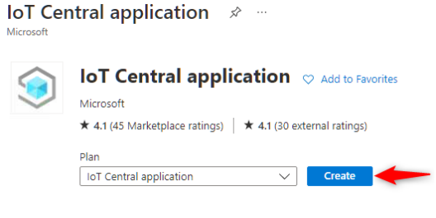

Figure 1: IoT central application

On the Basics tab, complete the fields as follows:

1. Subscription: Select the subscription to use for the application.
2. Resource group: Select a resource group or create a new one. To create a new one, select Create new and fill in the name you want to use. To use an existing resource group, select that resource group. For more information, see Manage Azure Resource Manager resource groups.
3. Resource name: Type in a name for the IoT central application.
4. Application URL: This will be automatically set to .azureiotcentral.com
5. Template: From the drop down, select "Custom application".
6. Region: Select the region in which the application will be located. Select a location that is geographically the closest.
7. Pricing Plan: Choose the appropriate pricing tier. The standard tier 0 is good to start prototyping. More details on pricing can be found under, https://azure.microsoft.com/en-us/pricing/details/iot-central

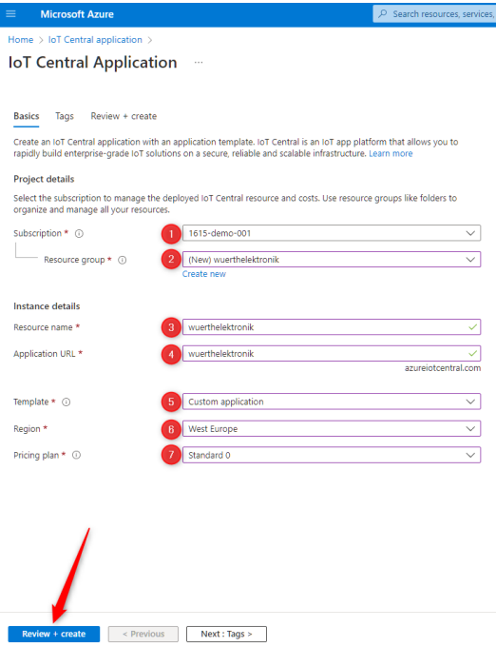

Figure 2: IoT central application parameters

1. Click on "Review + Create".
2. In the following page, review the terms and click on "Create".
3. Wait for the deploymet to complete. After the process is complete, click on "Go to resource" button to open the application.
4. Click on the IoT central application URL to open the newly created IoT central platform.
5. In the IoT central app open, "Permissions > Device connection groups" and note down the ID scope parameter for use in futher steps.

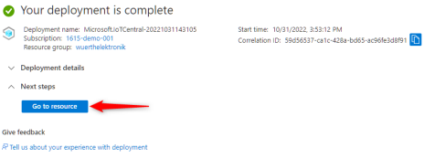

Figure 3: IoT central application deployment complete

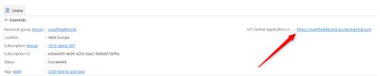

Figure 4: IoT central application URL

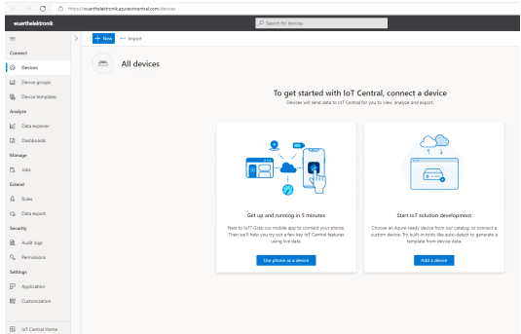

Figure 5: IoT central application homepage

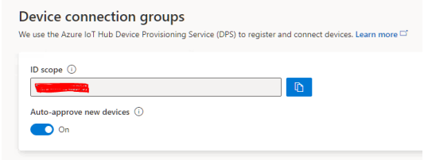

Figure 6: ID scope for the created IoT central application